**Objectives:** The objective of this lab was to create a network for an ISP that could provide Internet access for four companies. Based on each companies requirements, Jon and I were to design an addressing scheme that would provide the necessary amount of IP addresses while creating as few routing table entries as possible.

**Equipment List:** Jon and I used notebook paper and Dia Diagram Editor to design our network diagram.

**Notes & Observations:** When creating our network diagram, Jon and I decided to assign each company the first (or #0) network address to use and we used the second (or #1) network address to branch off of to create the next set of subnet addresses. We did this to stay consistent and to avoid any confusion.

**Diagrams, Flowcharts, & Figures:** [Link to PowerPoint](https://docs.google.com/presentation/d/1_bCaauL_e8rqaVhAI0VmjzAAMCOgG7AIXW2wYRPf1fc/edit?usp=sharing)

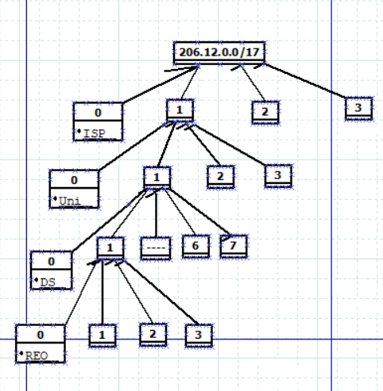

**References:** N/A

**Questions:** N/A

**Conclusion and Reflection:** Jon and I were able to provide each company with enough IP addresses to meet their requirements, however, we did end up providing the university with 548 more IP addresses than they needed and the local ISP with 3,192 excess IP addresses. The design we used provided excess IP addresses but allowed for only one entry on our routing table for each company. If we were to do this challenge again, Jon and I would use the first network address for the ISP and keep the second network address open for expansion if needed. Doing so would reduce the number of excess IP addresses as well as allow for growth if the ISP required it.